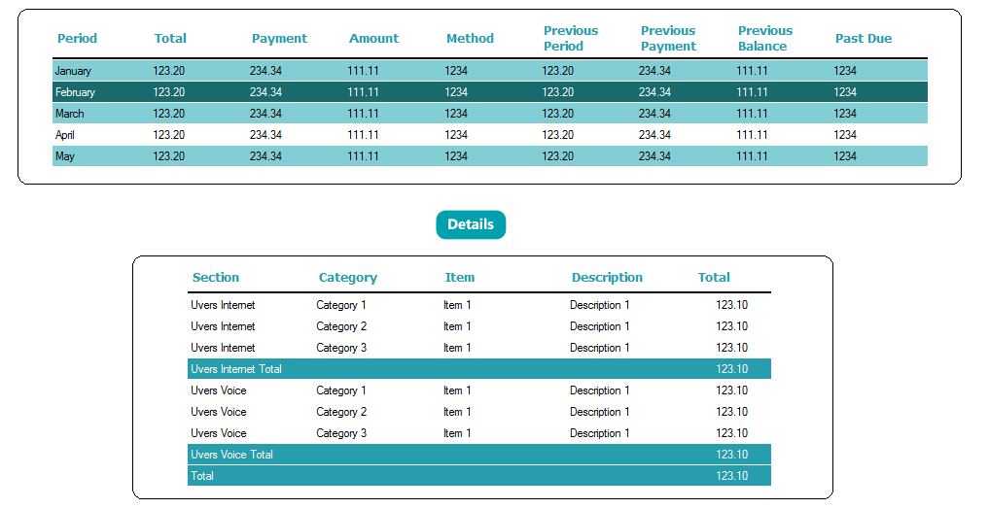

namespace UI

{

public partial class Form1 : Form

{

private Color BackGroundColor = Color.White;

private Color BackGroundTotalColor = Color.FromArgb(39, 158, 173);

private Color BackGroundAlternateColor = Color.FromArgb(131, 205, 213);

private Color BackGroundSelectedColor = Color.FromArgb(25, 106, 109);

private Color LetterHeaderColor = Color.FromArgb(39, 158, 173);

private Color LetterColor = Color.Black;

private Color LetterTotalColor = Color.White;

//Color.FromArgb(25,106,109);

public Form1()

{

InitializeComponent();

}

#region Load

private void Form1_Load(object sender, EventArgs e)

{

// TAKE AWAY THE LEFT COLUMN (SELECTION COLUMN)

//********************************************

dgBill.RowHeadersVisible = false;

dgDetails.RowHeadersVisible = false;

// TAKE AWAY BORDER AROUND GRID (BorderStyle = None )

//*******************************

// dgDetails.GridColor = Color.FromArgb(40, 40, 40);

// HEADER

// INCREASE HEADER HEIGHT

dgBill.ColumnHeadersHeightSizeMode = DataGridViewColumnHeadersHeightSizeMode.EnableResizing;

dgBill.ColumnHeadersHeight = 40;

// BACKGROUND AND FOREGROUND COLORS

dgBill.ColumnHeadersDefaultCellStyle.BackColor = BackGroundColor;

dgBill.EnableHeadersVisualStyles = false;

dgBill.ColumnHeadersDefaultCellStyle.ForeColor = LetterHeaderColor;

// Bold, Font, Size

dgBill.ColumnHeadersDefaultCellStyle.Font = new Font("Tahoma", 9.75F, FontStyle.Bold);

// TAKE AWAY GRID LINES ON HEADER

dgBill.ColumnHeadersBorderStyle = DataGridViewHeaderBorderStyle.None;

// DETAILS

// INCREASE HEADER HEIGHT ON DETAILS

dgDetails.ColumnHeadersHeightSizeMode = DataGridViewColumnHeadersHeightSizeMode.EnableResizing;

dgDetails.ColumnHeadersHeight = 30;

// BACKGROUND AND FOREGROUND COLORS

dgDetails.ColumnHeadersDefaultCellStyle.BackColor = BackGroundColor;

dgDetails.EnableHeadersVisualStyles = false;

dgDetails.ColumnHeadersDefaultCellStyle.ForeColor = LetterHeaderColor;

// TAKE AWAY GRID LINES ON HEADER (DETAILS)

dgDetails.ColumnHeadersBorderStyle = DataGridViewHeaderBorderStyle.None;

//dgDetails.ColumnHeadersDefaultCellStyle.Font = new Font("Arial", 12F, FontStyle.Underline, GraphicsUnit.Pixel);

// Bold, Font, Size

dgDetails.ColumnHeadersDefaultCellStyle.Font = new Font("Tahoma", 9.75F, FontStyle.Bold);

// DATA

// BACKGROUND AND FOREGROUND COLORS

dgBill.RowsDefaultCellStyle.BackColor = Color.White;

//dgBill.AlternatingRowsDefaultCellStyle.BackColor = Color.FromArgb(65, 65, 65);

dgBill.DefaultCellStyle.ForeColor = LetterColor;

dgBill.GridColor = BackGroundColor;

// ALLOW HORIZONTAL LINES ONLY

dgBill.CellBorderStyle = DataGridViewCellBorderStyle.SingleHorizontal;

// BACKGROUND AND FOREGROUND COLORS FOR DETAILS

dgDetails.RowsDefaultCellStyle.BackColor = BackGroundColor;

dgDetails.DefaultCellStyle.ForeColor = LetterColor;

// COLOR FOR GRID LINES ON DATA (NOT ON HEADER) FOR HORIZONTAL LINES

dgDetails.CellBorderStyle = DataGridViewCellBorderStyle.SingleHorizontal;

dgDetails.GridColor = BackGroundColor;

// LOAD

GetBills();

// GridView1();

GetAccounts();

}

#endregion

#region DEFINE STRUCTURE

private DataTable DefMaster()

{

DataTable Bills = new DataTable();

Bills.Columns.Add("Period", typeof(string));

Bills.Columns.Add("Total", typeof(string));

Bills.Columns.Add("Payment", typeof(string));

Bills.Columns.Add("Amount", typeof(string));

Bills.Columns.Add("Method", typeof(string));

Bills.Columns.Add("Previous Period", typeof(string));

Bills.Columns.Add("Previous Payment", typeof(string));

Bills.Columns.Add("Previous Balance", typeof(string));

Bills.Columns.Add("Past Due", typeof(string));

return Bills;

}

private DataTable DefDetail()

{

DataTable dt = new DataTable();

dt.Columns.Add("Section", typeof(string));

dt.Columns.Add("Category", typeof(string));

dt.Columns.Add("Item", typeof(string));

dt.Columns.Add("Description", typeof(string));

dt.Columns.Add("Total", typeof(string));

return dt;

}

#endregion

#region LoadBills

private void GetBills()

{

DataTable Bills = DefMaster();

Bills.Rows.Add("", "", "", "", "", "", "", "", "");

Bills.Rows.Add("January", "123.20", "234.34", "111.11", "1234", "123.20", "234.34", "111.11", "1234");

Bills.Rows.Add("February", "123.20", "234.34", "111.11", "1234", "123.20", "234.34", "111.11", "1234");

Bills.Rows.Add("March", "123.20", "234.34", "111.11", "1234", "123.20", "234.34", "111.11", "1234");

Bills.Rows.Add("April", "123.20", "234.34", "111.11", "1234", "123.20", "234.34", "111.11", "1234");

Bills.Rows.Add("May", "123.20", "234.34", "111.11", "1234", "123.20", "234.34", "111.11", "1234");

//dgGrid1.DataSource = Bills;

dgBill.DataSource = Bills;

// DRAW FOR FIRST ROW LIKE A BLACK LINE

//*************************************

if (dgBill.Rows.Count > 0)

{

dgBill.Rows[0].DefaultCellStyle.BackColor = Color.Black;

dgBill.Rows[0].Height = 3; // LOOK LIKE A LINE******

}

// dgBill.ColumnHeadersHeight = dgBill.Rows[0].Height * 3;

// ALTERNATE ROW BACKGROUND COLOR

for (int i = 1; i < dgBill.Rows.Count; i++)

{

if (i % 2 != 0) dgBill.Rows[i].DefaultCellStyle.BackColor = BackGroundAlternateColor;

}

// SET REAL HEIGH OF GRID

//***********************

dgBill.Height = (dgBill.Rows.Count * 22) + 30;

}

#endregion

#region LoadDetails

private void GetAccounts()

{

DataTable dt = DefDetail();

dt.Rows.Add("", "", "", "", "");

dt.Rows.Add("Uvers Internet", "Category 1", "Item 1", "Description 1", "123.10");

dt.Rows.Add("Uvers Internet", "Category 2", "Item 1", "Description 1", "123.10");

dt.Rows.Add("Uvers Internet", "Category 3", "Item 1", "Description 1", "123.10");

dt.Rows.Add("Uvers Internet Total", "", "", "", "123.10");

dt.Rows.Add("Uvers Voice", "Category 1", "Item 1", "Description 1", "123.10");

dt.Rows.Add("Uvers Voice", "Category 2", "Item 1", "Description 1", "123.10");

dt.Rows.Add("Uvers Voice", "Category 3", "Item 1", "Description 1", "123.10");

dt.Rows.Add("Uvers Voice Total", "", "", "", "123.10");

dt.Rows.Add("Total", "", "", "", "123.10");

dgDetails.DataSource = dt;

if (dgDetails.Rows.Count > 0)

{

dgDetails.Columns[0].Width = 130;

dgDetails.Columns[1].Width = 130;

dgDetails.Columns[2].Width = 130;

dgDetails.Columns[3].Width = 130;

dgDetails.Columns[4].Width = 80;

dgDetails.Columns[4].DefaultCellStyle.Alignment = DataGridViewContentAlignment.MiddleCenter;

for (int i = 0; i < dgDetails.Rows.Count; i++)

{

if (i == 0)

{

dgDetails.Rows[0].DefaultCellStyle.BackColor = Color.Black;

dgDetails.Rows[0].Height = 3;

}

string texto = dgDetails[0, i].Value.ToString();

if (texto.IndexOf("Total") > 0 || texto == "Total")

{

dgDetails.Rows[i].DefaultCellStyle.ForeColor = LetterTotalColor;

dgDetails.Rows[i].DefaultCellStyle.BackColor = BackGroundTotalColor;

//DataGridViewImageCell cell = dgDetails.Rows[i].Cells[1] as DataGridViewImageCell;

//cell.Value = (System.Drawing.Image)UI.Properties.Resources.Details_Left;

//dgDetails.Rows[i].Cells[1].Value = cell.Value;

// dgDetails.Rows[i].Cells[1].Value = (Image)UI.Properties.Resources.Details_Left;

// dgDetails.Rows[i].Cells[1].Value = (Bitmap)UI.Properties.Resources.Details_Left;

// dgDetails.Rows[i].Cells[1].Value = (Bitmap)System.Drawing.Image.FromFile(@"C:\tmp\Details_Left.png", true);

}

}

// SET REAL HEIGH OF GRID

//***********************

dgDetails.Height = (dgDetails.Rows.Count * 22) + 20;

//foreach (DataGridViewRow row in dgDetails.Rows)

//{

// DataGridViewImageCell cell = row.Cells[1] as DataGridViewImageCell;

// cell.Value = (System.Drawing.Image)UI.Properties.Resources.Details_Left;

//}

}

}

#endregion

#region rectangles

static void DrawRoundedRectangle(Graphics g, Pen p, int x, int y, int w, int h, int rx, int ry)

{

System.Drawing.Drawing2D.GraphicsPath path = new System.Drawing.Drawing2D.GraphicsPath();

path.AddArc(x, y, rx + rx, ry + ry, 180, 90);

path.AddLine(x + rx, y, x + w - rx, y);

path.AddArc(x + w - 2 * rx, y, 2 * rx, 2 * ry, 270, 90);

path.AddLine(x + w, y + ry, x + w, y + h - ry);

path.AddArc(x + w - 2 * rx, y + h - 2 * ry, rx + rx, ry + ry, 0, 91);

path.AddLine(x + rx, y + h, x + w - rx, y + h);

path.AddArc(x, y + h - 2 * ry, 2 * rx, 2 * ry, 90, 91);

path.CloseFigure();

g.DrawPath(p, path);

}

private void Form1_Paint(object sender, PaintEventArgs e)

{

DrawRoundedRectangle(e.Graphics, new Pen(Brushes.Black, 1), 140, 430, 720, 250, 10, 10);

//System.Drawing.Graphics graphicsObj;

//graphicsObj = this.CreateGraphics();

//Pen myPen = new Pen(System.Drawing.Color.Black, 1);

//Rectangle myRectangle = new Rectangle(20, 180, 950, 190);

//graphicsObj.DrawRectangle(myPen, myRectangle);

}

private void panel1_Paint(object sender, PaintEventArgs e)

{

// draw panel with rounded corner of dgBill grid

DrawRoundedRectangle(e.Graphics, new Pen(Brushes.Black, 1), 10, 10, 970, 180, 10, 10);

}

#endregion

#region grids

private void dgDetails_SelectionChanged(object sender, EventArgs e)

{

// to avoid Blue color on selected cell at the outset

dgDetails.ClearSelection();

}

private void dgBill_SelectionChanged(object sender, EventArgs e)

{

// to avoid Blue color on selected cell at the outset

dgBill.ClearSelection();

}

private void dgBill_CellClick(object sender, DataGridViewCellEventArgs e)

{

// ROW SELECTED, PAINT GREEN DARK

int fila = e.RowIndex;

if (fila > -1)

{

dgBill.Rows[fila].DefaultCellStyle.BackColor = BackGroundSelectedColor;

dgBill.Rows[fila].DefaultCellStyle.ForeColor = Color.White;

}

}

private void dgBill_RowLeave(object sender, DataGridViewCellEventArgs e)

{

// PAINT ROW DESELECTED

int fila = e.RowIndex;

if (fila > 0)

{

dgBill.Rows[fila].DefaultCellStyle.ForeColor = Color.Black;

if (fila % 2 != 0)

dgBill.Rows[fila].DefaultCellStyle.BackColor = BackGroundAlternateColor;

else

dgBill.Rows[fila].DefaultCellStyle.BackColor = BackGroundColor;

}

}

#endregion

}

}

**Grid properties**

BackgroundColor White

BorderStyle None

GridColor White

